San Jose State University

EE250 (Section 2) Fall 2019 Prof. Kamali

Solution to Problem Set #7

- Problem 6.5
- All the combinations are given in the following table.

 |  | 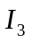 |  |  |  | 
0 | 0 | 0 | 8/27 | 0 | 0 | 0
0 | 0 | 1 | 4/27 | 1 | 0 | 1
0 | 1 | 0 | 4/27 | 1 | 0 | 1
0 | 1 | 1 | 2/27 | 2 | 0 | 1
1 | 0 | 0 | 4/27 | 1 | 0 | 1
1 | 0 | 1 | 2/27 | 2 | 0 | 1
1 | 1 | 0 | 2/27 | 2 | 0 | 1
1 | 1 | 1 | 1/27 | 3 | 1 | 1

Thus all the values of the triplet 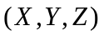with the joint pmf are as follows.

 | 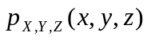
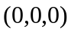 | 8/27
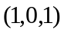 | 4/9
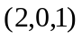 | 2/9
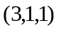 | 1/27

- It is easy to find marginal pmf’s as follows.

 | 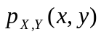
 | 8/27
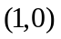 | 4/9
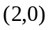 | 2/9
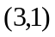 | 1/27

 | 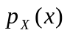
0 | 8/27
1 | 4/9
2 | 2/9
3 | 1/27

 | 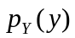
0 | 26/27
1 | 1/27

 | 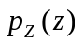
0 | 8/27
1 | 19/27

Clearly and are not independent because 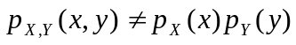. Likewise, , and are not independent because 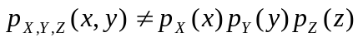

c) In this case all the combinations are given in the following table.

1 | 0 | 0 | 1/3 | 1 | 0 | 1
0 | 1 | 0 | 2/3x1/2=1/3 | 1 | 0 | 1
0 | 0 | 1 | 2/3x1/2=1/3 | 1 | 0 | 1

Thus the triplet can take only one value of with the probability of one.

- Problem 6.7
a) 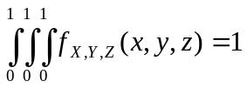

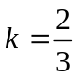

b) 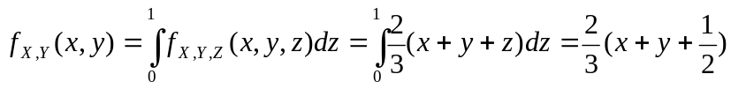

Due to Symmetry

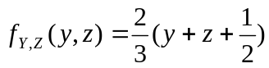

Thus

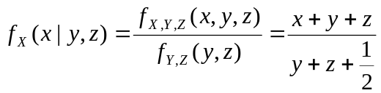

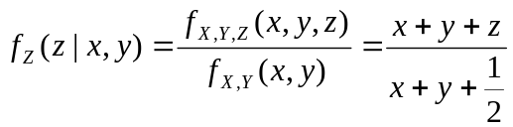

c) 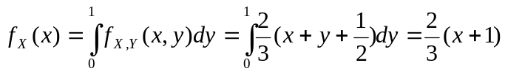

And due to Symmetry

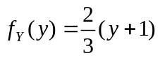 and 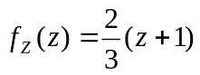

- Problem 6.21
a)
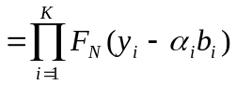

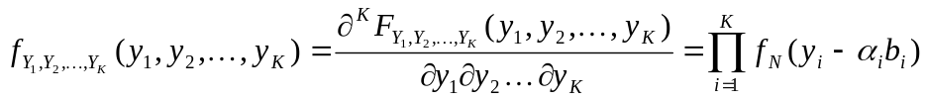

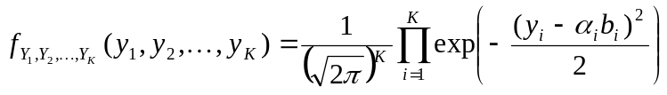

b) 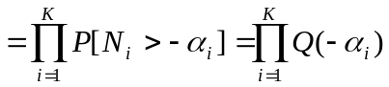

- Problem 6.41

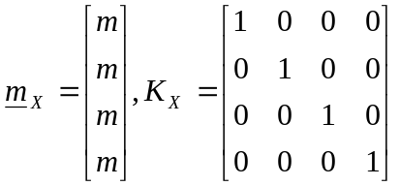

a) 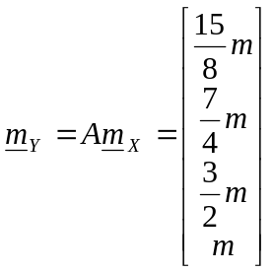, 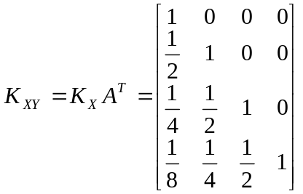,

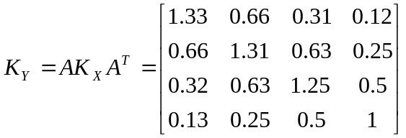

b) 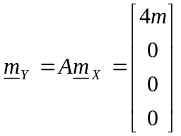, 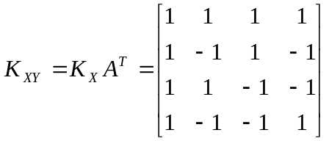,

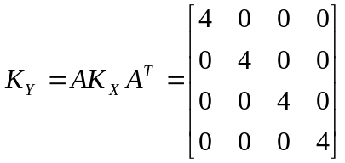

- [Final examination, Fall 2009] Suppose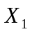,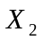, and 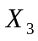 are three random variables defined as follows.

1. is a uniform random variable between [-3,3].
2. is a uniform random variable between [-2,2].
3. is a uniform random variable between [-1,1].
4. The correlation coefficients between these random variables are as follows.

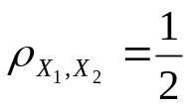, 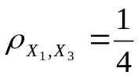, 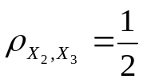

Find the covariance matrix 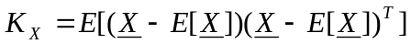 where 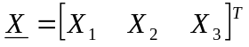.

Solution:

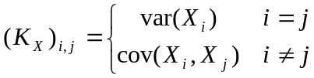

From the course the variance of a uniform random variable between 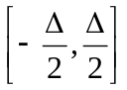 is 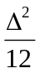.

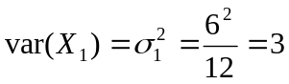, 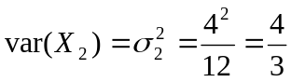, 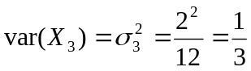

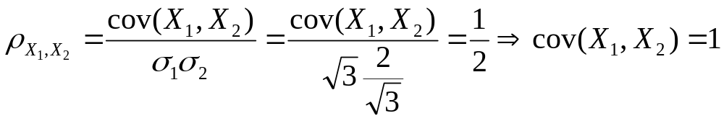
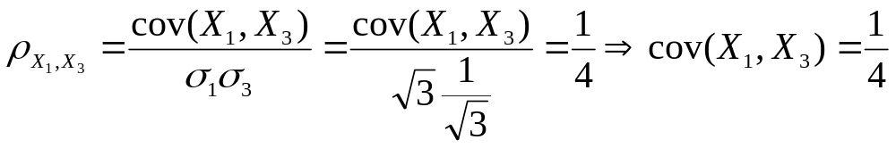
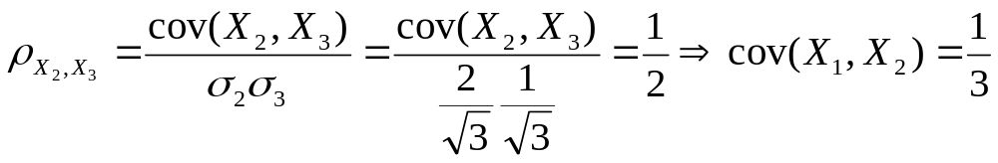
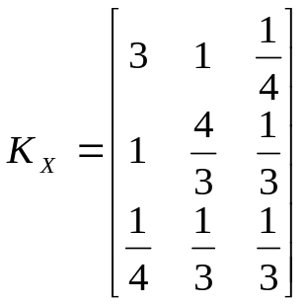

- [Final examination, Fall 2015] The covariance matrix of the random vector 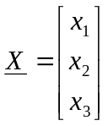is given as follows.

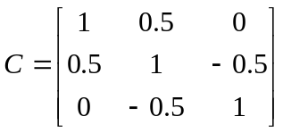

Find the correlation coefficient of 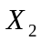and (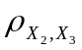).

Solution:

